Mek’s new GTAz AOI Range Provides the Perfect Combination of 3D and 2D Inspection
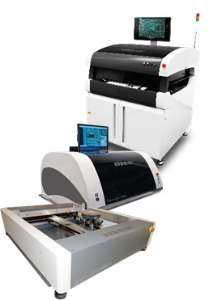
Mek (Marantz Electronics), has announced the launch of GTAz, its newest and most advanced optical head available on the company’s PowerSpector and SpectorBOX range of AOI machines.

The GTAz delivers true Stereoscopic imaging using its 9 high speed (90 Fps) cameras operating in full 24 bit color. This new generation optical head removes the need for expensive capture cards utilising Thunderbolt2 20GBs transfer speeds and full frame transfer. 3D from 9 camera views gives the ability to actually see the side of components rather than extruded 2D images from single camera systems. The result is a perfect combination of the 3D features such as verification of body height, tilt and coplanarity along with the 2D fast programming advantages and pin height and solder meniscus profile analysis, component presence/absence, polarity, value, angle, offset, color, extra part detection, solder ball detection and short detection.

Unique stereoscopic 3D imaging is achieved utilizing the full 9 cameras of the GTAz. The image differentials are merged and a vectorised map of the component is created, then analysed based on the programmer’s applied tolerances. This unique Selective 3D methodology requires no active light projection, and thus is both less costly than other 3D solutions and compact enough to be deployed in desk top systems.

Line Sourced DOAL (Direct On Axis Lighting) coaxial lighting system with high resolution Telecentric Optics enables the inspection of solder joints without shadow effects from tall components nearby as well as accurate inspection model building. Omnidirectional multi angle, multi colour LED lighting provides optimal illumination regardless of component direction.

The modular bottom up/top down SpectorBOX GTAz is optimized for the inspection of THT solder joints and the detection of solder bridges and solder balls.

Find out more at www.marantz-electronics.com

-ENDS-

About Mek (Marantz Electronics Ltd)
A former division of Marantz well known for its high quality Audio/Video products, Mek Japan (Marantz Electronics Kabushiki Kaisha), developed its first AOI system in 1994. Developed to inspect PCB assemblies for correct component placement and soldering, the company’s original AOI system was designed for use in Marantz factories. Proving to be a highly successful, cost-effective alternative to traditional human inspection, Mek developed its first generation commercial system in 1996. With a steadily growing installed base, MEK Japan and its European/American headquarters, Mek, have sold over 5000 units worldwide to date. Now well established as a leading force in AOI technologies, the company also manufactures a 5D post-print SPI system which combines 3D and 2D image processing methodologies to deliver unprecedented defect detection. At the beginning of March 2014 the company opened US offices in Las Vegas.

MEK Europe BV Contact | Agency Contact
Henk Biemans  MEK Europe  Polluxstraat 2B,  5047RB Tilburg  The Netherlands | Helena Osborn  Protean Inbound  Unit 1, Cutbush Court  Lower Earley  Reading, RG6 4UW  UK
Tel: +31 40 7114111  Email: henk.biemans@mek-europe.com  www.marantz-electronics.com | Tel: +44 1189 759880  Email: helena@proteaninbound.com  www.proteaninbound.com

